MCCS Back to School and Health and Safety Plan,
September 2020
Updated October 28, 2020
Updated February 2021
Students will be organized into “learning groups”—a group of students and staff that work closely together and interact mainly with each other. In elementary, the learning group size is set at 60, since it is more challenging for younger students to maintain physical distance. In our case, most elementary and middle classes will be a learning group, which means they will be learning together, playing together, and sitting together. During outside breaks, they may play with students in their learning groups, as long as they minimize physical and prolonged face-to-face contact. At MCCS, our student cohorts, based on where students are in the building (add staff to these numbers) are:
Learning group | Washrooms | Entrances/Exits
KA and B (36) | Between KG classrooms | Across from KG
1 and 2B (44) | Primary by staff washroom | Primary end
2A and 3A and B (52) | Kitchen | Lobby to playground
4 and 5 (53) | 4—Across hall  5—Across hall/Shop | 4—Across from Grade 4  5—Shop
6 and 8 (57) | Downstairs across from Grade 4 | Door facing shops
7A and B (36) | Downstairs across from Grade 4 | Door facing shops
9-12 (95) | Upstairs and Gym | Lobby to parking lot

Notes:
- Middle and secondary students wear masks at all times, except when standing or seated at their desks, chairs, or tables, eating or drinking at their desks, and when physically distanced outside
- Middle school learning groups stagger breaks by 5 minutes (e.g. Grade 7A and B go by bells; Grade 6A and B and 8 go 5 minutes later); eliminates crowding before, during, and after breaks
- Only grade 9-12 use the gym change rooms; the other students change in “their” washroom
- All students use only “their” washroom
- K-12 staff mask at all times, except when standing or seated at their desks/chairs, teaching from their desks or workstations, eating or drinking, or when physically distanced outside

To reduce interaction between learning groups and minimize physical contact, we will do two things:
- Playground will be divided into sections, that students will rotate through on a daily basis
- Grade 9-12 is one learning group, so they will spend their lunch time on one section of the playground
In secondary, the learning group size is set at 120, since secondary students are better able to physically distance, practice hand hygiene, and recognize if they are experiencing symptoms of COVID-19. In our case, this allows grade 9-12 students to become one learning group, which means they can continue taking courses together (as the grade 10-12 students do currently), taking their breaks together, and associating together at school. Within a learning group, students and staff need to maintain physical distancing as much as possible and they still need to minimize physical contact. Outside a learning group, physical distancing for middle and secondary students and all staff is still required.
The following physical distancing strategies will be implemented where possible:
- We will avoid close greetings (e.g., hugs, handshakes) and regularly remind students to keep your “hands to yourself”.
- We will spread people out into different areas: We will use different classroom and learning environment configurations to allow distance between students and adults (e.g., different desk and table formations) and avoid face-to-face contact. In all areas, we have the option of using additional empty classrooms to increase physical distancing.
- We will minimize the number of different teacher(s) and educational assistant(s) that interact with groups of students throughout the day (i.e. minimize the amount of mixing between students and different staff in the setting).
- We will take activities that involve movement, including those for physical health and education, outside.
- Playgrounds are a safe environment, and we will encourage appropriate hand-hygiene practices before, during, after outdoor play.
- We will incorporate more individual activities or activities that encourage more space between students and staff.
- For younger students, we will adapt group activities to minimize physical contact and reduce shared items. Elementary students will be taught about “physical distancing” and “minimizing physical contact”
- For adolescent students, we will minimize group activities and avoid activities that require physical contact.
- We will hold a minimal amount of assemblies and other school-wide events. Any gatherings will be with learning groups only. Once spaced at least six feet apart and seated or standing in place, masks may be removed.
- Staff will not share food (birthday treats, etc. must be pre-plated and include utensils or it must be pre-packaged)
- Staff will not eat food at the same table as others and will maintain at least a six foot distance during eating times.
- Staff rooms and other shared areas for staff follow WorkSafeBC guidance on Offices: Protocols for returning to operation
  - For example: Minimize the number of people using previously shared office equipment or other items (photocopiers, coffee machines, microwave ovens, etc.). Shared equipment should be cleaned and disinfected after each use.
- Monday morning openings and Friday closings will take place in the library with staff spaced at least six feet apart. Once seated six feet apart, masks can be removed.
  - Masks will be used when entering and exiting shared space
- Staff will be spaced at least six feet apart during pro-d sessions: Once seated six feet apart, masks can be removed.
- If/when staff need to work together at tables during pro-d sessions, they need to wear masks.
Students have extra responsibilities: Wash or sanitize their hands when they enter and leave school and before and after breaks, including bathroom breaks and lunch breaks. They must also label their personal items and not share them. See the following chart for when students and staff should perform hand hygiene at school:
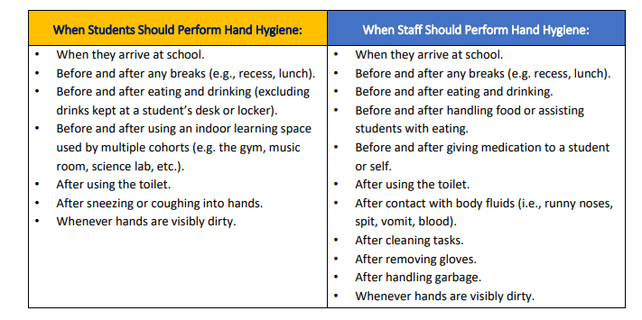
Mask Use
For elementary students, mask use is a parental choice. For older students (middle and secondary) and staff, masks are to be worn at all times except:
--when seated or standing at their desk, chair, or work station
--when physically distanced outside
--when eating or drinking, at their desks/tables
Face shields don’t replace masks, except where staff are serving students who need to respond to lip-reading or visual facial cues, in which case other physical barriers (e.g. plexi glass) must also be in place.
Clear masks (covering nose and mouth but leaving the mouth in sight i.e. not a mouth shield) may be used for students who need to lip read or see the educators face.
Masks are to be worn when singing.
Bus Transportation
Similar to last June, for bussing we will follow the recommendations below:
- Busses will be cleaned and disinfected following the BC Centre for Disease Control guidelines
- Students will have their own seat, unless sharing with a member of their learning group
- Middle and secondary students will wear face masks on the bus at all times
  - Middle school and secondary students will wear a mask from when they enter the bus to when they enter their classroom and are seated at their desks (morning) and from when they leave their desk to when they leave the bus (afternoon)
  - No mask=no bus ride
  - Mask off during bus ride=one week of no bussing
- Students will sit in consistent and assigned seating
- Bus drivers will keep up to date passenger lists to share with public health if contact tracing needs to occur
- Bus drivers will be provided with face masks and face shields
- In order to help decrease the density on our busses, we encourage parents to bring their children if that is possible or easy or for students to bike or walk to school if they live close by and that is safe. Grade 11 and 12 students that drive will be strongly encouraged to take their siblings along, so as to reduce the number of students on the bus.
- School buses: Public health measures have been implemented to keep school buses clean and safe. Students should clean their hands before and after riding the school bus. Buses will be loaded to reduce contact and students in middle school and high school will be required to wear a mask on the school bus. Buses will be cleaned and disinfected regularly (https://www2.gov.bc.ca/assets/gov/education/kindergarten-to-grade-12/covid/covid19-backtoschool-factsheet.pdf)
Travel by staff and students: Staff or students (grade 6-12) who travel outside BC, will be encouraged to wear a mask at all times inside the school building for 14 days after their return. This is a school initiative above the Ministry of Education requirements.
Additional Measures – cleaning, disinfecting, and administrative measures
Of course, regular cleaning and disinfecting are essential to preventing the transmission of COVID-19 and that will continue to occur. This includes a daily general cleaning and disinfecting and an extra cleaning at lunchtime when we will disinfect high-touch surfaces, including water fountains, door knobs/handles, light switches, toilet and faucet handles, tables, desks, chairs, and keyboards.
Shared equipment (PE and Music) and teaching aids (clipboards, whiteboards, pens, plastic bins for transporting materials, etc.) must be disinfected.
Physical Education
PE classes should continue to focus on spreading students out as much as possible, reducing physical contact, and eliminating prolong physical contact or crowding.
PE should be outside as much as possible.
For middle and high school students:
Same as above, plus;
For low intensity activities (walking, stretching, playing catch, etc.), students should wear a mask when indoors and unable to stay six feet apart;
Volleyball and badminton would be considered moderate intensity.
For high intensity activities (hockey, soccer, basketball, and running) indoors, students should be at least six feet apart.
Doing skills training rather than games will help, as well as reducing the number of students on the court (e.g. 3 on 3 rather than 5 on 5).
Another way to reduce physical contact will be by using floor markings and posters to address traffic flow throughout the school. Students will be taught to travel single file on the right side of the hallway and to use only their designated entrance and exit door.
Visitors, including parents and volunteers, should only enter the school if they are essential to support student-learning activities (e.g. practicum students, occupational therapist, speech and language pathologist, etc.). All visitors must complete the daily health check at the school entrance, wear masks, and sanitize their hands: The school must keep a list of the date, names and contact information for all visitors who enter the school, so they are asked to visit the main office first, before proceeding.
Guidelines for visitors (e.g. show and tell of puppies, etc.):
  - Teachers must communicate COVID safety measures (masks, hand sanitizer, physical distancing, etc.)
  - Visitors must sign in at the office
  - Visitors should do their show and tell outside
  - Show and tell should happen to only one learning group at a time
Fresh air is great! Staff will teach outside as much as feasible, will teach with open windows and doors, and have ceiling fans on to improve ventilation and air flow as much as feasible.
The staff room, library, gym, and copier rooms will have occupancy limits posted. Staff washrooms are individual washrooms. Staff will also take breaks at separate times to reduce the pressure on the staff room. At all times, staff should physically distance at least six feet. Staff should reduce close, face-to-face interactions, even when wearing a mask.
Stay Home When Sick
Students and staff should stay at home when new symptoms of illness develop. The key symptoms to watch for are fever, chills, cough, shortness of breath, loss of sense of smell or taste, nausea, vomiting and diarrhea.
- If the staff or student (or their parent) indicates that the symptoms are consistent with a previously diagnosed health condition and are not unusual for that individual, they may return to school. No assessment or note is required from a health care provider.
- For mild symptoms without fever, students and staff can monitor at home for 24 hours. If symptoms improve, they can return to school without further assessment.
- If symptoms include fever, or if after 24 hours, symptoms remain unchanged or worsen, seek a health assessment. A health assessment can include calling 8-1-1, a primary care provider like a physician or nurse practitioner, or going to a COVID-19 testing centre.
Stay Home When Required to Self-Isolate
The following students, staff or other persons must stay home and self-isolate:
- A person confirmed by public health as a case of COVID-19; or
- A person confirmed by public health as a close contact of a confirmed case or outbreak of COVID-19; or
- A person who has travelled outside of Canada in the last 14 days.
Daily Health Check
- School administrators should ensure parents, caregivers, school staff and other adults routinely entering the school are aware of their responsibility to assess themselves daily for key symptoms of illness prior to entering the school. (i.e. perform a daily health check).
- Parents and caregivers should assess their child daily for key symptoms of illness before sending them to school (i.e. perform a daily health check for their child).
- Staff and other adults should assess themselves daily for key symptoms of illness prior to entering the school (i.e. perform a daily health check).
Similar to last year, parents have some extra responsibilities. Parents must monitor their child daily for symptoms and not send their child to school if they are sick. As well, parents should encourage their child to minimize physical contact with other students, including friends. See the following chart for a “Daily Health Check” example that parents could complete prior to sending students to school.
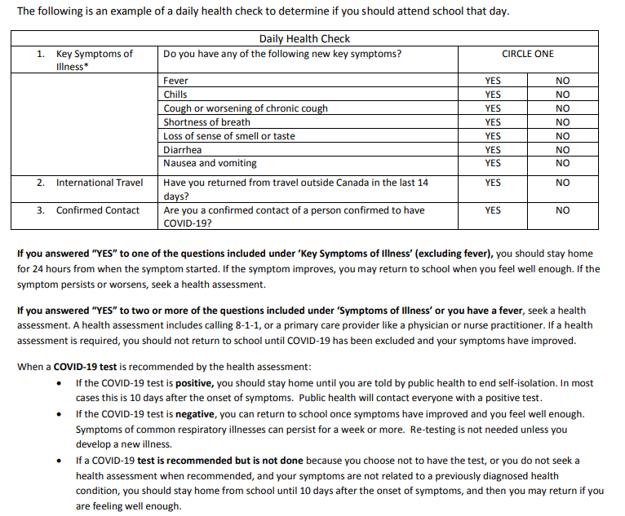
- If a child has any new symptoms of illness, they must not go to school.
- If staff or any adult has any new symptoms of illness, they must not enter the school.
If someone in the household has symptoms or are identified as a close contact
- Any household members or close contacts of someone with diagnosed Covid-19 should not attend school until the date directed by Public Health. Please be as clear as possible with public health about how well the person with Covid-19 is able to self-isolate from the rest of the household – Public Health will make individualized recommendations about how long contacts should self-isolate based on this information. Generally, if people cannot self-isolate from the rest of their household, the household contacts’ self-isolation will be extended until 14 days after the person with Covid-19 is released from self-isolation by Public Health.
- If one or more people in a student or staff member’s house has symptoms of Covid-19, household members should not attend school until all people with symptoms have received a negative Covid-19 result. Please have a very low threshold for testing, because we know Covid-19 is circulating broadly in our community right now. Testing with even a single symptom (eg a runny nose) is recommended when a person has been or suspects they have been in contact with a person who has Covid-19.

If someone develops symptoms at school
Included below is a chart that outlines protocols we will follow if staff or students develop symptoms. It is crucial to remember that students and staff who experience seasonal allergies or other COVID-19-like symptoms, which are related to an existing condition, can continue to attend school when they are experiencing these symptoms as normal. If they experience any change in symptoms, they should seek assessment by a health-care provider.
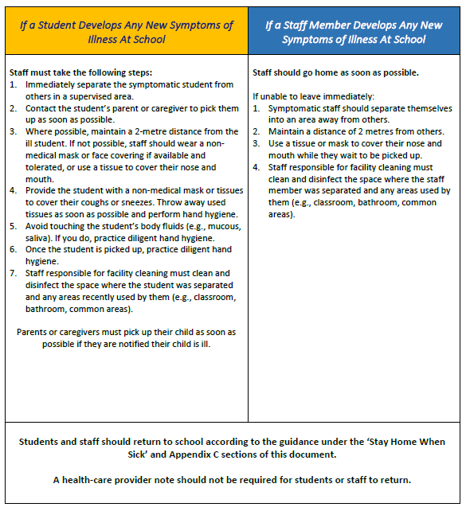

As a summary, the following chart outlines the main school-based control measures we are using:
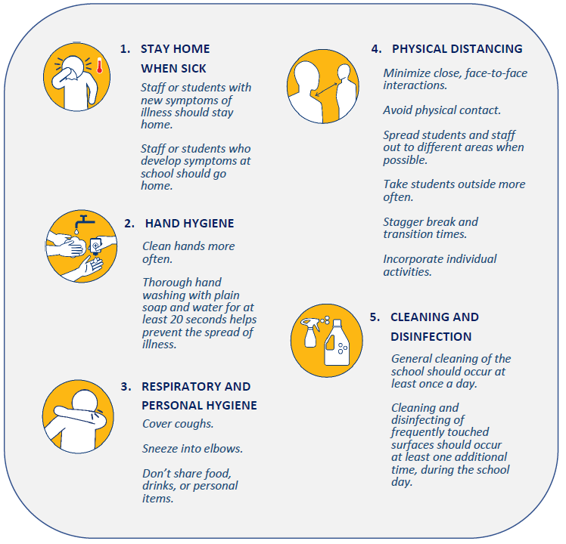
We are returning because being in school is critical for learning, as well as mental and physical well-being. Students are returning to school because it has been deemed safe for them to do so—all Canadian provinces have students returning. Schools are controlled environments where safety protocols can be implemented to mitigate the spread of the virus.
The Health and Safety Committee members have discussed and collaborated on this plan and all staff with First Aid training understand the new protocols to use during the COVID pandemic and have been provided with the WorkSafeBC “OFAA protocols during the COVID-19 pandemic” (https://www.worksafebc.com/en/resources/health-safety/information-sheets/ofaa-protocols-covid-19-pandemic?lang=en)

Health and Safety Committee members:
Jan Neels—Chair
John Giesbrecht—Co-chair
Caroline Van Saane—Secretary
Stephan Hoogendijk
Christina Kooij

